114學年度國中小學生普及化運動方案樂樂棒球彰化縣複賽 預備報名表
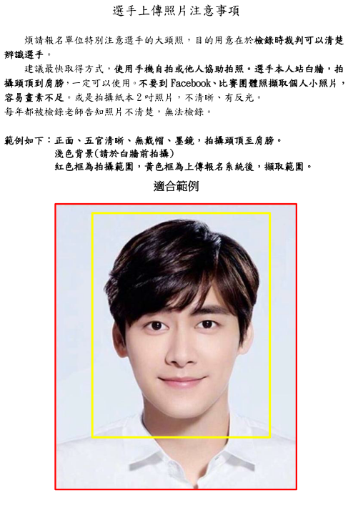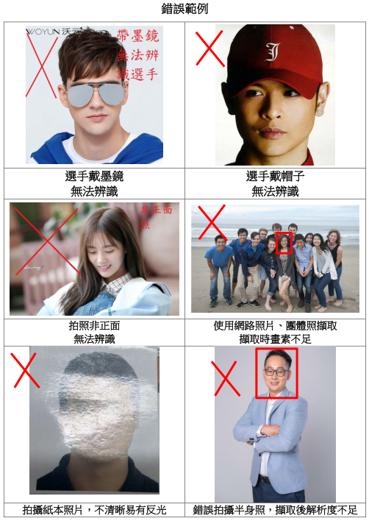
手持手機，直立拍攝頭頂至肩膀即可
114學年度國中小學生普及化運動方案樂樂棒球彰化縣複賽 預備報名表
隊名 | 例：幸福國小 |  |  |  | 簡稱 | 例：幸福 |  |  |  | 組別 |  | □三□四□五□六年級
領隊 |  |  |  |  | 導師 |  |  |  |  |  | 教練
聯絡人及手機 |  |  |  |  |  |  |  |  | MAIL
通訊地址
序號 |  | 姓名 |  | 出生年月日 |  |  |  | 身份證字號 |  |  |  |  |  | 性別 | 照片
01 |  |  |  |  |  |  |  |  |  |  |  |  |  |  | 請準備  檔案
02 |  |  |  |  |  |  |  |  |  |  |  |  |  |  | □
03 |  |  |  |  |  |  |  |  |  |  |  |  |  |  | □
04 |  |  |  |  |  |  |  |  |  |  |  |  |  |  | □
05 |  |  |  |  |  |  |  |  |  |  |  |  |  |  | □
06 |  |  |  |  |  |  |  |  |  |  |  |  |  |  | □
07 |  |  |  |  |  |  |  |  |  |  |  |  |  |  | □
08 |  |  |  |  |  |  |  |  |  |  |  |  |  |  | □
09 |  |  |  |  |  |  |  |  |  |  |  |  |  |  | □
10 |  |  |  |  |  |  |  |  |  |  |  |  |  |  | □
11 |  |  |  |  |  |  |  |  |  |  |  |  |  |  | □
12 |  |  |  |  |  |  |  |  |  |  |  |  |  |  | □
13 |  |  |  |  |  |  |  |  |  |  |  |  |  |  | □
14 |  |  |  |  |  |  |  |  |  |  |  |  |  |  | □
15 |  |  |  |  |  |  |  |  |  |  |  |  |  |  | □
序號 |  | 姓名 |  | 出生年月日 |  |  |  | 身份證字號 |  |  |  |  |  | 性別 | 照片
16 |  |  |  |  |  |  |  |  |  |  |  |  |  |  | □
17 |  |  |  |  |  |  |  |  |  |  |  |  |  |  | □
18 |  |  |  |  |  |  |  |  |  |  |  |  |  |  | □
19 |  |  |  |  |  |  |  |  |  |  |  |  |  |  | □
20 |  |  |  |  |  |  |  |  |  |  |  |  |  |  | □
21 |  |  |  |  |  |  |  |  |  |  |  |  |  |  | □
22 |  |  |  |  |  |  |  |  |  |  |  |  |  |  | □
23 |  |  |  |  |  |  |  |  |  |  |  |  |  |  | □
24 |  |  |  |  |  |  |  |  |  |  |  |  |  |  | □
25 |  |  |  |  |  |  |  |  |  |  |  |  |  |  | □
26 |  |  |  |  |  |  |  |  |  |  |  |  |  |  | □
27 |  |  |  |  |  |  |  |  |  |  |  |  |  |  | □
28 |  |  |  |  |  |  |  |  |  |  |  |  |  |  | □

