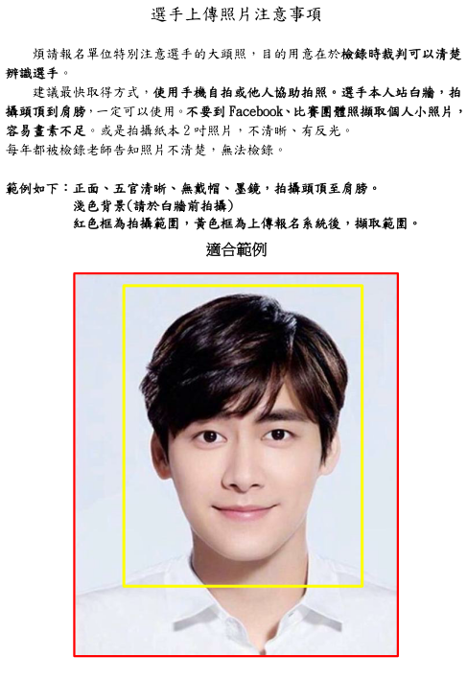 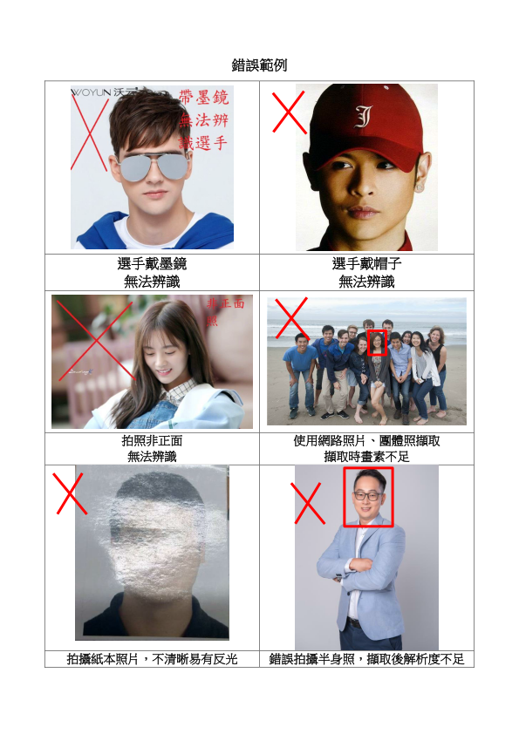

**手持手機，直立拍攝頭頂至肩膀即可**

|  |  |  |  |  |  |  |  |  |  |  |  |  |  |  |  |
| --- | --- | --- | --- | --- | --- | --- | --- | --- | --- | --- | --- | --- | --- | --- | --- |
| **113學年度國中小學生普及化運動方案樂樂棒球彰化縣複賽 預備報名表** | | | | | | | | | | | | | | | |
| 隊名 | 例：幸福國小 | | | | 簡稱 | 例：幸福 | | | | 組別 | | □三□四□五□六年級 | | | |
| 領隊 |  | | | | 導師 | |  | | | | 教練 | |  | | |
| 聯絡人及手機 | | |  | | | | | | MAIL | |  | | | | |
| 通訊地址 | | |  | | | | | | | | | | | | |
| 序號 | | 姓名 | | 出生年月日 | | | | 身份證字號 | | | | | | 性別 | 照片 |
| 01 | |  | |  | | | |  | | | | | |  | 請準備  檔案 |
| 02 | |  | |  | | | |  | | | | | |  | □ |
| 03 | |  | |  | | | |  | | | | | |  | □ |
| 04 | |  | |  | | | |  | | | | | |  | □ |
| 05 | |  | |  | | | |  | | | | | |  | □ |
| 06 | |  | |  | | | |  | | | | | |  | □ |
| 07 | |  | |  | | | |  | | | | | |  | □ |
| 08 | |  | |  | | | |  | | | | | |  | □ |
| 09 | |  | |  | | | |  | | | | | |  | □ |
| 10 | |  | |  | | | |  | | | | | |  | □ |
| 11 | |  | |  | | | |  | | | | | |  | □ |
| 12 | |  | |  | | | |  | | | | | |  | □ |
| 13 | |  | |  | | | |  | | | | | |  | □ |
| 14 | |  | |  | | | |  | | | | | |  | □ |
| 15 | |  | |  | | | |  | | | | | |  | □ |
| 序號 | | 姓名 | | 出生年月日 | | | | 身份證字號 | | | | | | 性別 | 照片 |
| 16 | |  | |  | | | |  | | | | | |  | □ |
| 17 | |  | |  | | | |  | | | | | |  | □ |
| 18 | |  | |  | | | |  | | | | | |  | □ |
| 19 | |  | |  | | | |  | | | | | |  | □ |
| 20 | |  | |  | | | |  | | | | | |  | □ |
| 21 | |  | |  | | | |  | | | | | |  | □ |
| 22 | |  | |  | | | |  | | | | | |  | □ |
| 23 | |  | |  | | | |  | | | | | |  | □ |
| 24 | |  | |  | | | |  | | | | | |  | □ |
| 25 | |  | |  | | | |  | | | | | |  | □ |
| 26 | |  | |  | | | |  | | | | | |  | □ |
| 27 | |  | |  | | | |  | | | | | |  | □ |
| 28 | |  | |  | | | |  | | | | | |  | □ |
| 29 | |  | |  | | | |  | | | | | |  | □ |
| 30 | |  | |  | | | |  | | | | | |  | □ |